## **City Council**

2018-2019 City of Newton

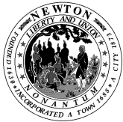

# Memorandum

To: City Council

From: Chairs of Programs & Services, Public Facilities & Public Safety Committees

Re: Meeting Cancellation

Date: December 14, 2018

The Public Facilities, Programs & Services and Public Safety & Transportation Committee meetings regularly scheduled for December 19, 2018 are cancelled.

The Committees will meet on Wednesday, January 9, 2019.

Enjoy your weekend.